Practical: 1 | Implementation and Time analysis of sorting algorithms. Bubble sort, Selection sort, Insertion sort, Merge sort and Quicksort
29/07/2026

Aim: To Implement and Time analysis of sorting algorithms. Bubble sort, Selection sort, Insertion sort, Merge sort and Quicksort.

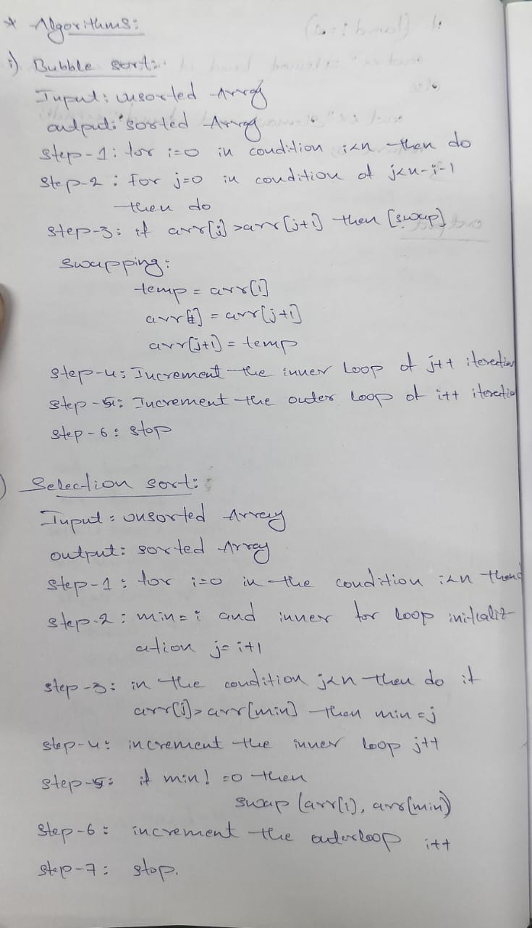
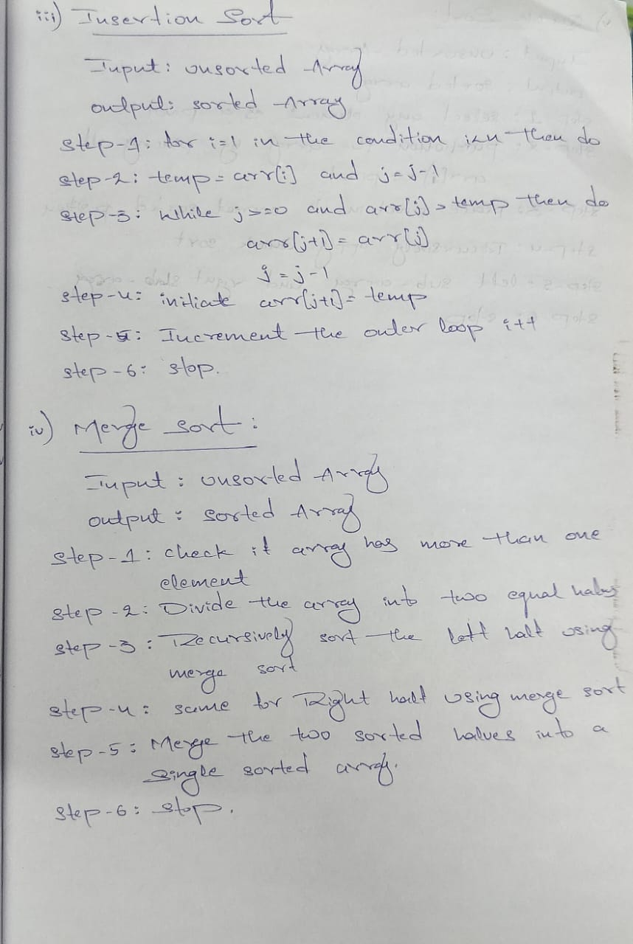
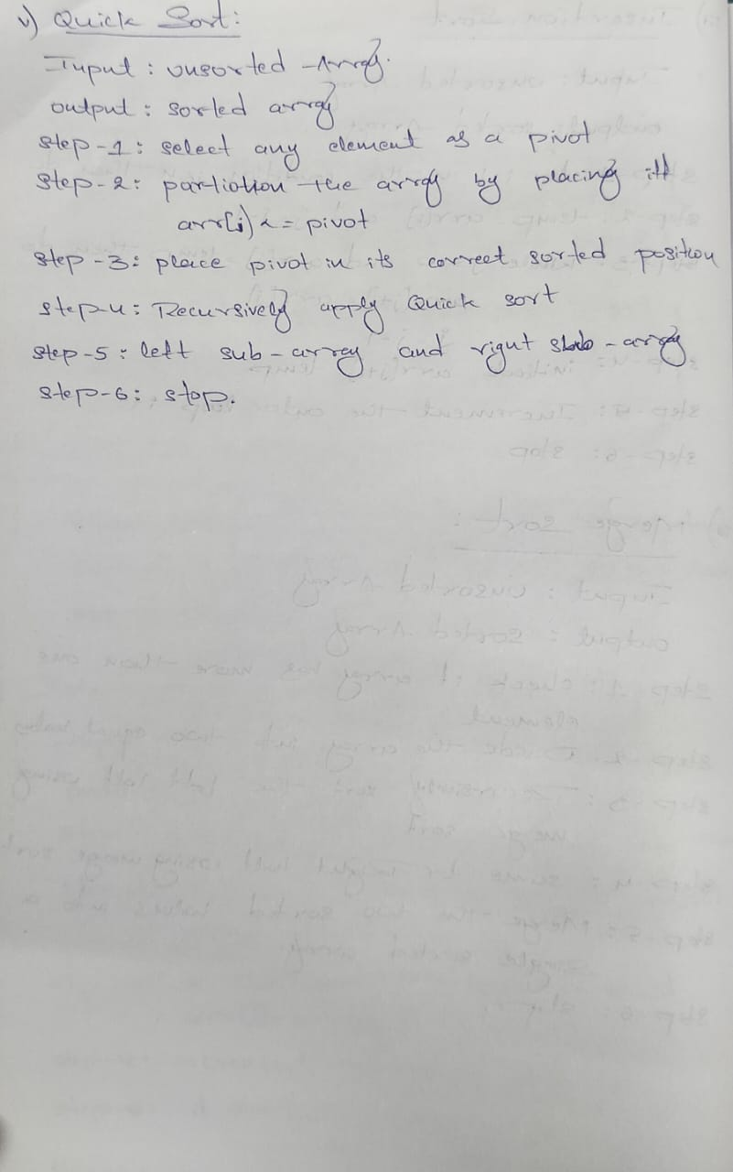

Program:

1. Bubble sort, selection sort, Insertion sort
#include<iostream>
using namespace std;

class classname{
public:
void Func(){
int array1[100];
int input,i;
cout<<"Enter the size of array: ";
cin>>input;
array1[input];
cout<<"Enter the Elements in array:\n";
for(int i=0; i< input; i++){
cin>>array1[i];
}
int n = sizeof(array1)/sizeof(array1[0]);
display(array1,input);
cout<<"\n\n";
Bubble(array1,input);
cout<<"\n\n";
selection(array1,input);
cout<<"\n\n";
insertion(array1,input);
cout<<"\n\n";
// quickSort(array1, 0, n-1);
}
void display(int array1[],int n){
cout<<"Your Array is:\n";
for(int i = 0; i<n; i++){
cout<<array1[i]<<" ";
}

}
void Bubble(int array1[],int n){
cout<<"Bubble sorted array:\n";
for(int i=0;i<n;i++){
for(int j=0; j<n-i-1; j++){
if(array1[j] > array1[j+1]){
int temp = array1[j];
array1[j] = array1[j+1];
array1[j+1] = temp;
}

}
}
display(array1,n);
}
void selection(int array1[],int n){
cout<<"selection sort Array:\n";
for(int i = 0; i<n; i++){
int min = i;
for(int j=i+1; j<n; j++){
if(array1[j] < array1[min]){
min = j;
}
if(min != 0){
int temp = array1[i];
array1[i] = array1[min];
array1[min] = temp;
}
}
}
display(array1,n);
}

void insertion(int array1[],int n){
cout<<"insertion sort Array:\n";
for(int i=1;i<n;i++){
int temp = array1[i];
int j = i-1;
while(j>=0 && array1[j]>temp){
array1[j+1] = array1[j];
j=j-1;
}
array1[j+1] = temp;

}
display(array1,n);
}

int main(){
classname obj;
obj.Func();
return 0;
}

2. Quick sort and merge sort:
#include<iostream>
using namespace std;

//------------------- Swap Function -------------------
void swap(int* a, int* b) {
int temp = *a;
*a = *b;
*b = temp;
}

//------------------- Quick Sort -------------------
int partition(int arr[], int start, int end) {
int pivot = arr[end];
int i = start - 1;

for (int j = start; j < end; j++) {
if (arr[j] <= pivot) {
i++;
swap(&arr[i], &arr[j]);
}
}

swap(&arr[i + 1], &arr[end]);
return i + 1;
}

void quickSort(int arr[], int start, int end) {
if (start < end) {
int pi = partition(arr, start, end);

quickSort(arr, start, pi - 1);
quickSort(arr, pi + 1, end);
}
}

//------------------- Merge Sort -------------------
void merge(int arr[], int left, int mid, int right) {
int n1 = mid - left + 1;
int n2 = right - mid;

int L[n1], R[n2];

// Copy data to temporary arrays
for (int i = 0; i < n1; i++)
L[i] = arr[left + i];

for (int j = 0; j < n2; j++)
R[j] = arr[mid + 1 + j];

int i = 0, j = 0, k = left;

// Merge the temporary arrays
while (i < n1 && j < n2) {
if (L[i] <= R[j]) {
arr[k] = L[i];
i++;
}
else {
arr[k] = R[j];
j++;
}
k++;
}

// Copy remaining elements
while (i < n1) {
arr[k] = L[i];
i++;
k++;
}

while (j < n2) {
arr[k] = R[j];
j++;
k++;
}
}

void mergeSort(int arr[], int left, int right) {
if (left < right) {
int mid = (left + right) / 2;

mergeSort(arr, left, mid);
mergeSort(arr, mid + 1, right);

merge(arr, left, mid, right);
}
}
void display(int array1[], int n) {
for (int i = 0; i < n; i++) {
cout << array1[i] << " ";
}
cout << endl;
}

int main() {
int arr[] = {9, 9, 7, 78, 5};
int n = sizeof(arr) / sizeof(arr[0]);
cout << "Original Array:\n";
display(arr, n);
//Quick Sort
quickSort(arr, 0, n - 1);
cout<<endl;
cout<<"Quicksort sorted array: ";
display(arr, n);
// Merge Sort
mergeSort(arr, 0, n - 1);
cout<<endl;
cout<<"mergesort sorted array: ";
display(arr, n);
return 0;
}

Output:

1.

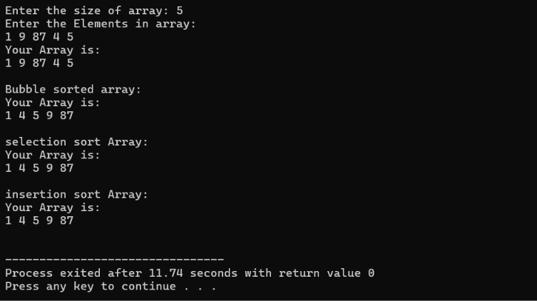

2.

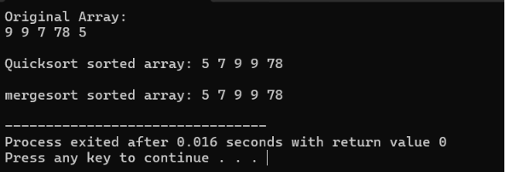

Time Complexity:

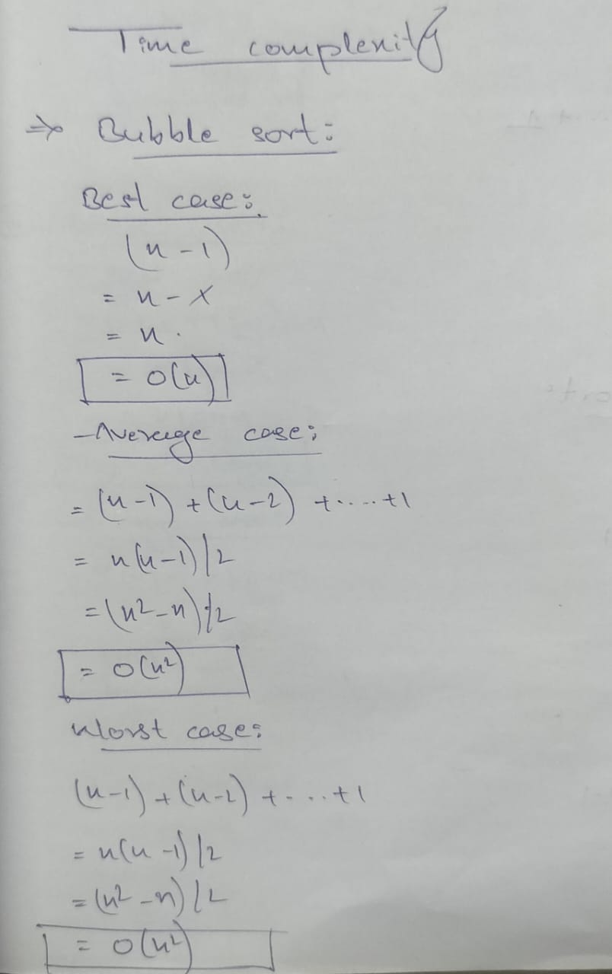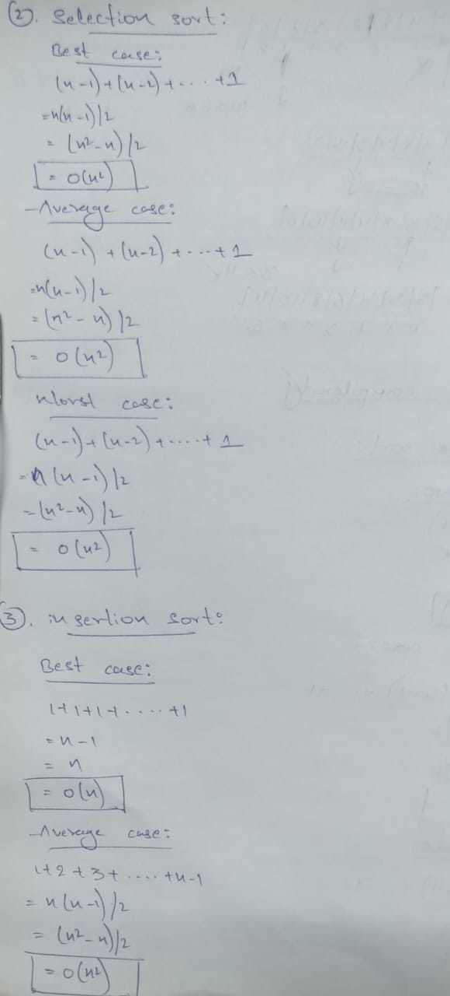
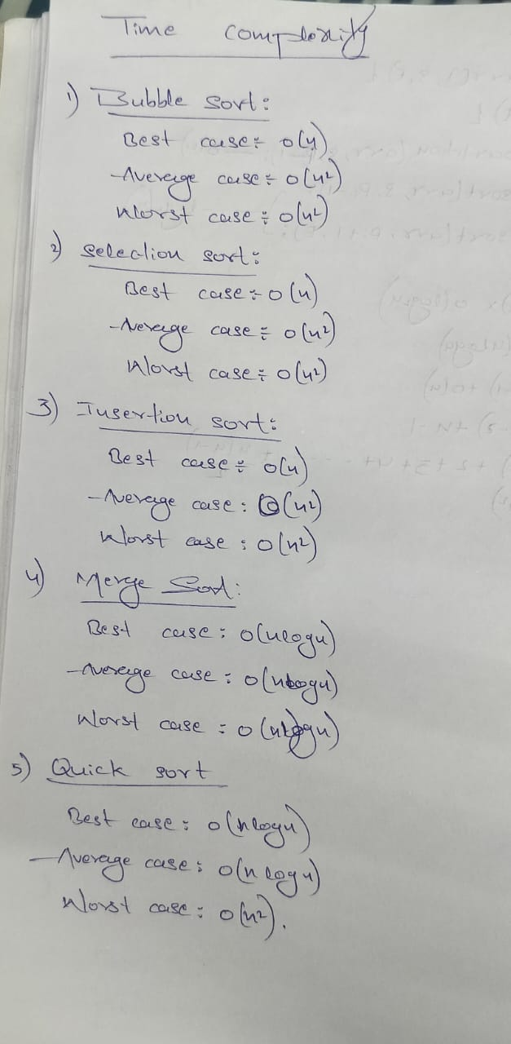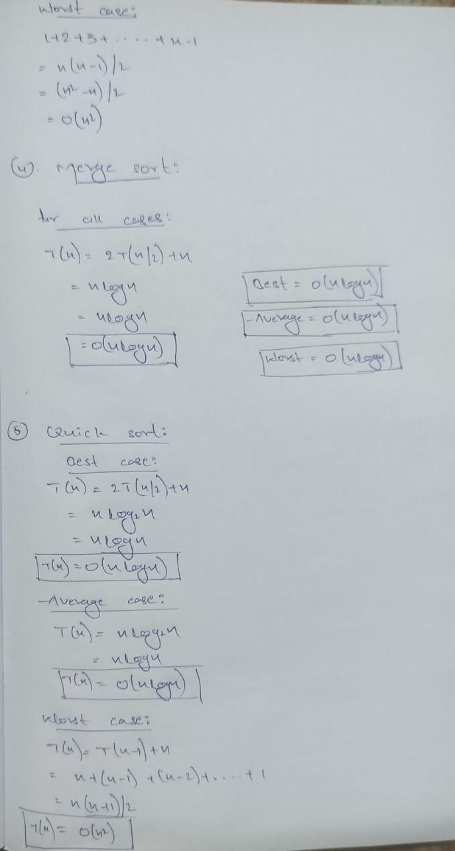

Conclusion:
Hence, By Implementing and analysing of sorting algorithms. Bubble sort, Selection sort, Insertion sort, Merge sort and Quicksort.
The time complexity plays an important role in the logical part of the program. And the Programs are successfully executed.

